Asia-China-Coins-Atlantika-9. [Wang Mang](http://en.wikipedia.org/wiki/Wang_Mang)

9. [Wang Mang](http://en.wikipedia.org/wiki/Wang_Mang) was a nephew of the [Dowager Empress Wang](http://en.wikipedia.org/wiki/Empress_Wang_Zhengjun), In AD 9, he usurped the throne, and founded the [Xin Dynasty](http://en.wikipedia.org/wiki/Xin_Dynasty). He introduced a number of currency reforms which met with varying degrees of success. The first reform, in AD 7, retained the Wu Zhu coin, but reintroduced two versions of the knife money:

* **Yi Dao Ping Wu Qian** (Chinese: 一刀平五千; pinyin: yīdāo píng wǔqiān; literally "One Knife Worth Five Thousand") on which the Yi Dao characters are inlaid in gold.
* 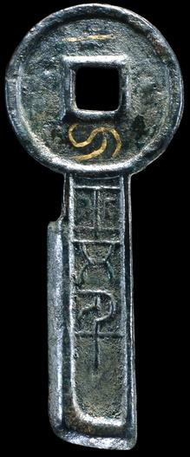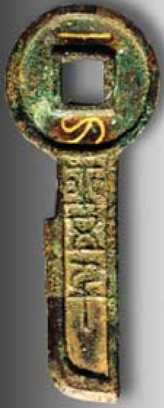
* Left BM, Right Shanhai Bank Museum
* 契刀五百 **Qi Dao Wu Bai** (Chinese: 契刀五百; pinyin: qì dāo wǔbǎi; literally "Inscribed Knife Five Hundred")

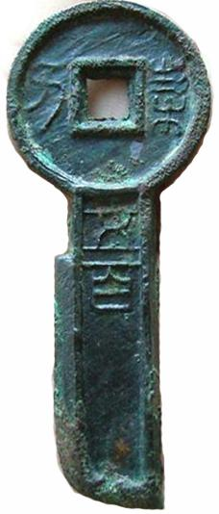

Between AD 9 and 10 he introduced an impossibly complex system involving [tortoise shell](http://en.wikipedia.org/wiki/Tortoiseshell_material), [cowries](http://en.wikipedia.org/wiki/Cowrie), gold, silver, six round copper coins, and a reintroduction of the [spade money](http://en.wikipedia.org/wiki/Spade_money) in ten denominations.

**The Six Coins. AD 9-14.**

* Xiao Quan Zhi Yi (Chinese: 小泉直一; pinyin: xiǎoquán zhí yī; literally "Small Coin, Value One")
* Yao Quan Yi Shi (Chinese: 么泉一十; pinyin: yǎo quán yīshí; literally "Baby Coin, Ten")
* You Quan Er Shi (Chinese: 幼泉二十; pinyin: yòu quán èrshí; literally "Juvenile Coin, Twenty")
* Zhong Quan San Shi (Chinese: 中泉三十; pinyin: zhōng quán sānshí; literally "Middle Coin, Thirty")
* Zhuang Quan Si Shi (Chinese: 壯泉四十; pinyin: zhuàng quán sìshí; literally "Adult Coin, Forty")
* Da Quan Wu Shi (Chinese: 大泉五十; pinyin: dàquán wǔshí) is a round coin with a nominal value of fifty Wu Zhu.

**The Ten Spades. AD 10-14.**

* Xiao Bu Yi Bai (Chinese: 小布一百; pinyin: xiǎo bù yībǎi; literally "Small Spade, One Hundred")
* Yao Bu Er Bai (Chinese: 么布二百; pinyin: yǎo bù èrbǎi; literally "Baby Spade, Two Hundred")
* You Bu San Bai (Chinese: 幼布三百; pinyin: yòu bù sānbǎi; literally "Juvenile Spade, Three Hundred")
* Xu Bu Si Bai (Chinese: 序布四百; pinyin: xù bù sìbǎi; literally "Ordered Spade, Four Hundred")
* Cha Bu Wu Bai (Chinese: 差布五百; pinyin: chà bù wǔbǎi; literally "Servant Spade, Five Hundred")
* Zhong Bu Liu Bai (Chinese: 中布六百; pinyin: zhōng bù liùbǎi; literally "Middle Spade, Six Hundred")
* Zhuang Bu Qi Bai (Chinese: 壯布七百; pinyin: zhuàng bù qībǎi; literally "Adult Spade, Seven Hundred")
* Di Bu Ba Bai (Chinese: 第布八百; pinyin: dì bù bābǎi; literally "Graduate Spade, Eight Hundred")
* Ci Bu Jiu Bai (Chinese: 次布九百; pinyin: cì bù jiǔbǎi; literally "Lower Spade, Nine Hundred")
* Da Bu Heng Qian (Chinese: 大布衡千; pinyin: dà bù héng qiān; literally "Large Spade, Weight One Thousand")

According to the History of Han:

The people became bewildered and confused, and these coins did not circulate. They secretly used Wu Zhu coins for their purchases. Wang Mang was very concerned at this and issued the following decree:

“Those who dare to oppose the court system and those who dare to use Wu Zhus surreptitiously to deceive the people and equally the spirits will all be exiled to the Four Frontiers and be at the mercy of devils and demons.”

The result of this was that trade and agriculture languished, and food became scarce. People went about crying in the markets and the highways, the numbers of sufferers being untold.

In AD 14, all these tokens were abolished, and replaced by another type of spade coin and new round coins.

* **Huo Bu** (Chinese: 貨布; pinyin: huò bù; literally "Money Spade")
* **Huo Quan** (Chinese: 貨泉; pinyin: huòquán; literally "Wealth/Money Coin")

According to Schjöth, Wang Mang wished to displace the Wu Zhu currency of the Western Han, owing, it is said, to his prejudice to the *jin* (Chinese: 金; pinyin: jīn; literally "gold") radical in the character *zhu* (Chinese: 銖; pinyin: zhū) of this inscription, which was a component part of the character Liu, the family name of the rulers of the House of Han, whose descendant Wang Mang had just dethroned. And so he introduced the *Huo Quan* currency. One of the reasons, again, that this coin circulated for several years into the succeeding dynasty was, so the chroniclers say, the fact that the character *quan* (Chinese: 泉; pinyin: quán) in the inscription consisted of the two component parts *bai* (Chinese: 白; pinyin: bái; literally "white") and *shui* (Chinese: 水; pinyin: shuǐ; literally "water"), which happened to be the name of the village, Bai Shui in Henan, in which the [Emperor Guang Wu](http://en.wikipedia.org/wiki/Emperor_Guangwu_of_Han), who founded the Eastern Han, was born. This circumstance lent a charm to this coin and prolonged its time of circulation. The Huo Quan did indeed continue to be minted after the death of Wang Mang – a mould dated AD 40 is known.

**Bu Quan** (Chinese: 布泉; pinyin: bù quán; literally "Spade Coin") was known later as the *Nan Qian* (Chinese: 男錢; pinyin: nán qián; literally "Male Cash"), from the belief that if a woman wore this on her sash, she would give birth to a boy. Eventually, Wang Mang's unsuccessful reforms provoked an uprising, and he was killed by rebels in AD 23.[[34]](http://en.wikipedia.org/wiki/Ancient_Chinese_coinage?action=render" \l "cite_note-34)